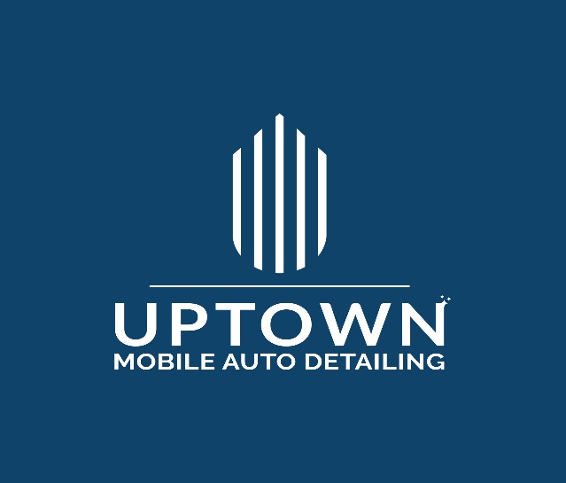

Service Agreement
Uptown Mobile Auto Detailing

Introduction

In this Service Agreement “Agreement,” “you” and “your” refer to each “customer,” including each person (representative) you designate to act on your behalf. “Uptown Mobile Auto Detailing,” and “we,” “us,” and “our” refer collectively to Uptown Mobile Auto Detailing. This Agreement explains our obligations to you, and your obligations to us in relation to the service(s) you purchase. If you designate a person to act on your behalf “Designated representative,” you agree that this person is your representative with full authority to act on your behalf with respect to such services and your vehicle. Please refer to the accompanying Service Order for specific information regarding the day and time of your requested detailing service (job) specific to your vehicle. By using our service, you agree to the terms of this agreement, without modification by you.

Terms of Service, Payments Terms and Fees

The fee for our service is the agreed dollar amount indicated as “Total Cost” on the invoice. The terms of service is for the amount of time reserved by us to complete the “job” you requested with the designated services offered. The amount of time reserved is an estimated assumption since the condition of each vehicle may vary. It is possible that the job could be more than the time reserved. In the event that your job is completed in less time, the fee will remain the same and will not be adjusted. For our Interior, Exterior and Uptown Detail, if the job takes longer than the time reserved, we will stay as long as needed to complete the job at no additional cost, up to a maximum of one (1) hours. Additional time beyond one (1) hours will be charged at the rate of $50. If a job takes longer than estimated, we will let you know how much additional time it will take.

If you have extra/special requests, please let us know at the time the service invoice is written. Any alterations or changes after the initial service package has been issued may result in an extra charge. Any alterations or changes to the initial service package must be approved in writing between you and Uptown Mobile Car Detailing before any extra work begins. Any changes to the fees and/or time, be it verbal or in writing. Wil not affect the substance of this agreement and all the terms herein will still apply with the new rate and/or time.

Payment is due on the date of service. We accept credit and major credit cards (Visa, MasterCard and American Express) Please do not leave any payments in the vehicle.

Late Payments and Fees

All fees are due and payable on the date the services are rendered (due date)

Cancellations and Refund

You or Uptown Mobile Auto Detailing may cancel a job at any time for any reason. Please provide at least 24-hours’ notice. If Uptown Mobile Auto Detailing cancels your job for whatever reason, you will receive a full refund of any prepaid fees if applicable. Uptown Mobile Auto Detailing is a mobile service and performs out-of-doors. If weather conditions prevent us from doing the job, your appointment will be cancelled, and neither you nor Uptown Detailing will not be held liable in anyway. If and when this occurs, we will reschedule or you may request a 100% refund of any prepaid fees if applicable. All refunds will be issued in the manner in which the original amount was paid (Credit Cards will be credited) If we arrive during the scheduled day and time and are turned away for ANY reason, OR cannot gain access to your vehicle for ANY reason, then you are still liable to pay the full amount of the agreed upon fee. In addition, we will wait for not more than 15 minutes from the beginning of a scheduled job, at which time the job becomes a cancellation by you and you are liable to pay the full amount of the agreed upon fee.

Determining the Cost of Your Auto Detailing

Uptown Mobile Auto Detailing will conduct a consultation with you and see the vehicle before we can provide you the total cost and estimate the time before we will accept a job. We reserve the right to adjust any advertised price after we have visually inspected your vehicle.

Quality of Service

We want you to be satisfied with our service. For your convenience, and our quality control, we may provide you with a checklist indicating the various services we provided while cleaning and/or detailing your vehicle. Uptown Mobile Auto Detailing help to recondition and restore your vehicle. No services offered are guaranteed to completely restore the vehicle to any previous or new condition. We will try our absolute best to restore the vehicle to the best condition possible and within the constraints of our resources, time, and expertise. We will conduct a final inspection together, with you, at the end of the job. If, after the final inspection, you find our service unsatisfactory, please contact us within 24 hours so we can address your concern. Uptown Mobile Auto Detailing will not be held liable for any concerns after 24 hours of job completion or if you did not complete the final inspection with us.

Insurance, Accidents, Pre-existing Condition and Damage

Uptown Mobile Auto Detailing is fully insured. We are fully insured to operate whenever you may need service. Our insurance covers every customer and vehicle. Notwithstanding negligence, Uptown Detailing cannot be held responsible for damage to the vehicle while in our care. We are as careful as possible and if something does get damaged while detailing your vehicle, we will advise you of the incident. We will check the condition of your vehicle for any existing damage during the pre-inspection. Additional pre-existing damage may be noted as the vehicle is cleaned or detailed. We will take pictures of your vehicle immediately before we begin the job. You agree not to hold Uptown Detailing liable for pre-existing damage.

Preparing your Vehicle

Prior to our arrival, please remove all items from your vehicle. Please empty out the glove compartment and any storage compartments. Please remove all cash, jewellery, and other valuables. If for any reason you do not wat a particular area of your vehicle to be cleaned or detailed, please let us know before we begin the job. We will package any personal items we find while servicing your vehicle into plastic bags and remove them from the vehicle. We will return the items to your vehicle once we’re finished. You agree to not hold us responsible for damage or loss to any item left inside or outside the vehicle.

What we will not do

Pull out or remove any seats or equipment.
Reinstall any child safety seat.

Operating/Moving your Vehicle

You authorize us to operate or to move your vehicle, only if it is necessary to do so. This may include moving the vehicle so that it can be parked in a more secure area.

Keys

Please make sure the keys to the vehicle are available to us.

Providing Feedback and Photos

We ask for your feedback. Please send an email (anton@uptowndetailing.ca) or use our contact form on the website (www.uptownmobileautodetailing.ca) and let us know if there are ANY concerns –good or bad. We also request that you allow Uptown Mobile Auto Detailing to use pictures of your vehicle for marketing purposes and to publish on its website (www.uptownmobileautodetailing.ca) or Facebook page, https://www.facebook.com/uptowndetailing. No personal identification of the vehicle or its owner will be published.

Referrals

You will receive a $10 discount on your next service for referring a new client to Uptown Detailing. This discount becomes effective after the referred clients first service and payment. Please email us the new clients name and address and we will ensure this credit reflects on your future invoice. Only one referral discount allowed per service.

Information Collection and Use

We require the collection of certain information from you in order to respond to your inquiries, provide automotive appearance services, and to ensure that we can provide a quality and personalized service. When you inquire about our services via in-person, telephone, email, or through our website, the information we may collect includes your name, address, telephone numbers (including mobiles), email address, and the year, make and model of your vehicle. We require this information in order to respond to your inquiry.

If you decide to purchase our services, in addition to the above information, we will collect the vehicle registration and identification number. If you are not available when your vehicle is detailed, we will collect the name of a person you authorize to act as your agent and his or her telephone number. The information we collect is not legally required, but is required in order to provide you with our services. If you choose not to provide this information, we may not be able to provide you with our services.

Once you decide to purchase a service, we will communicate with you via email, telephone or email to provide the information and services you request and to manage your account. You may not opt-out of these transactional communications, which are not promotional in nature. We offer promotional communications via Facebook, Instagram and Linkedin.

Contacting Us

Online: www.uptownautodetailing.ca
Email: anton@uptownautodetailing.ca
Telephone: 226-505-8292

Address:
Uptown Mobile Auto Detailing, LLC
PO Box 1234
Waterloo, ON

